Attachment 2: Guidebook to Prepare a Pre-Test Plan Document

Table of Contents for Pre-Test Plan Format
Following is the first element of the step-by-step guide to completing a pre-test plan. We suggest that this Table of Contents be retained with the appropriate page numbers filled in. If this Table of Contents is not used, all the necessary elements outlined in it should be contained in your pre-test plan.
List of Figures
Figure 1: Test Program Organization
Figure 2: Process Flow Diagram
Figure 3: Control Equipment Schematic
Figure 4: Sampling Location Schematic
Figure 5: Sample Recovery Flow Diagram
Figure 6: Sample Analysis Flow Diagram
Figure 7: Velocity Data Sheet

List of Tables
Table 1: Test Matrix
Table 2: Process Flow Diagram
Table 3: Summary Table Format of Emission Data
Table 4: Test Personnel and Responsibilities
Table 5: Proposed Daily Test Schedule

- Introduction
  - Summary of Test Program
  - Previous Certificate of Approval Source Test and Results
  - Test Program Organization
  - Organizational Chart

- Source and Sampling Location Description
  - Process Description
  - Control Equipment Description
  - Exhaust System Characteristics

- Test Program
  - Objectives
  - Test Matrix

- Sampling Locations
  - Flue Gas
  - Process Sampling Locations

- Sampling and Analytical Procesures
  - Test Methods
  - Process Data

- Internal QA/QC Activities
  - QA/QC Procedures
  - QA/QC Check Lists
  - QA/QC Checks for Data Reduction and Validation
  - Sample Identification and Custody

- Reporting and Data Reduction Requirements
  - Report Format
  - Data Reduction and Summary

- Plant Safety Requirements
  - Safety Responsibilities
  - Safety Requirements

- Personnel Responsibilities and Test Schedule
  - Test Personnel Responsibilities and Detailed Schedule
  - Test Preparations

- References

Appendices
A - Certificate of Approval/Control Order
B - Test Methods
C - Calibration Records:
Pitot Tube
Dry Gas Meter
Thermocouple Nozzle
D - Preliminary Survey Data
E - Field and Laboratory Forms
F - Qualifications of Sampling Team

Pre-Test Plan Format

Introduction

1.1 Summary of Test Program
In this chapter, write a brief summary that identifies or states, as applicable, the following in the order presented:
- Responsible groups or organizations.
- Overall purpose of the emission test.
- Certificate of Approval Number/Control Order.
- Industry.
- Name of plant.
- Plant location.
- Processes of interest.
- Air pollution control equipment, if applicable.
- Emission points and sampling locations.
- Pollutants to be measured in tabular form.
- Method of Analysis for each pollutant.
- Expected dates of test.

1.2 Previous Certificate of Approval Source Test and Results

1.3 Test Program Organization
- Company Name (as in Certificate of Approval):
Company Address:
Plant Location:
Plant Coordinator: Name:
Position:
Telephone No.:
Fax No.:
Directions and/or map to the test site:

- Ministry of Environment and Energy District Office:
Name of local Environmental Officer:
Telephone No.:
Fax No.:

- Sampling Company:
Project Co-ordinator:
Telephone No.:
Fax No.:
Sampling Team:

- Analytical Laboratory:
Project Co-ordinator:
Telephone Number:
Fax No.:

Provide all the above information for any other parties or organizations participating in the source testing program.

1.4 Organization Chart
Provide an organization chart.

Figure 1: Test Program Organization Chart
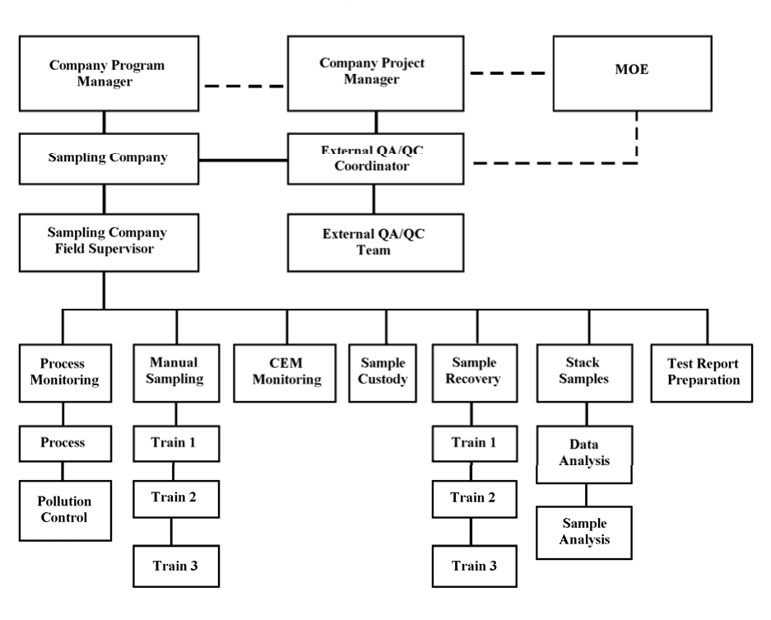

2.0 Source Description

2.1 Process Description
All production rates and operating parameters should be at levels of maximum production within the approved operating range of the Equipment as required by the Certificate of Approval or Control Order (or at the operating level stated in the legal document used by the Ministry). If the production rates and operating parameters at which the test is run are at a lower rate, it may lead to reconsideration of the Certificate of Approval conditions.

In this chapter of the pre-test specify the North American Industry Classification System (NAICS) code (or codes) that apply to the facility, for classification of the emissions discharging from the facility.

This chapter consists of two parts: the process description and the process operation. The process description should familiarize the reader of the pre-test plan with the process and provide an insight understanding on how the unit operates. The process operation portion provides the reader with a general view of the process in terms of production and scheduling of processes.

2.1.1 Description of the process
State the plant's main line of product (or products) and its production rate. Give a brief description of the overall plant processes and operating areas. Provide a complete step- wise description of the process under study, including size and operating capacity of relevant units/equipment; nature of the source (i.e., batch, continuous, cyclic); identify fuels and feed materials used; identify by-products and final product; list design feed rates or batch sizes and actual feed and production rates; and indicate the relationship of the source or process under investigation to the overall or other plant process (i.e., other lines or processes that may affect the emissions of the source or process under investigation).

This subchapter should also include a flow diagram of the overall process (Figure 2), accompanied by an appropriate text describing the stages of the process. In this flow diagram, trace the process from the beginning to the end. Identify the major operations. Show only those gas, liquid, and solid flow streams that relate to the process under scrutiny. Indicate emission and process stream test points.

2.1.2 Process Operation
In the process operation subchapter, the normal plant operating schedule in hours per day, days per week, and weeks per year should be given. The overall plant design capacity and average operating rates should be given in terms of product, by-product, and feed rates of fuels and raw materials. Indicate peak operating capacity. Include summaries of estimated process information concerning rates of production and feed over the sampling periods. Include any factor or operating condition that might affect the testing or emissions.

List of key operating parameters:

- Number of shifts at plant
- Shift hours
- Normal Operating hours for Equipment:
- hours/day
- days/week weeks/year
- Warm-up Time for Equipment
- Total number of lines
- Normal number of lines operating simultaneously
- Maximum number of lines operating simultaneously
- Indicate if Process is
- Batch/Cyclic
- Continuous Other
- Components of Product
- Components of Feed
- Type of Product
- Type of Feed
- Certificate of Approval Maximum Feed Rate/Maximum Production Rate
- Production Rate of Product
- Production Rate of Feed
- Temperature (°C) of Process
- Any other Parameters Required by Certificate of Approval or relevant to the process.

Note: The sampling consultant must verify with the plant operator that the process is running under the required capacity (as per Certificate of Approval, Control Order or maximum operating capacity); that the monitoring, collection and recording of the process data is appropriate; and that the recorded and reported process data is representative of the process under study.

2.2 Control Equipment Description
In this chapter, familiarize the reader of the pre-test plan with the number, types and location of all the air pollution control units that pertain to the process under study. Include the configuration of the pollution control systems and provide an insight understanding on how each unit operates.

- Discussion of typical control equipment operation and, include a schematic (Figure 3).

- List of key operating parameters and physical configurations:
- Baghouse
- Cleaning mode:
- Reverse flow
- Pulse jet flow
- Mechanical
- Filter Media:
- Type:
- Treatments
- Filter bag dimensions:
- Length:
- Diameter:
- Type of bag support:
- Cage
- Rings
- Number of filter bags
- Cloth to air ratio
- Cleaning to filtering flow ratio
- Number of compartments
- Frequency of cleaning
- Pressure drop
- Frequency of change of filter bags

- Scrubber
- General Type:
- Wet:
- Dry:
- Specific Type:
- Venturi:
- Centrifugal/cyclonic:
- Flow submersion:
- Conditioning tower:
- Other (specify):
- Type of nozzles
- Pressure at the nozzles
- Water flow rate
- Pressure drop
- Scrubber operating temperature
- Scrubbing solution
- Type of media (conditioning tower)
- Direction of scrubbing solution with respect to the exhaust gas:
- Concurrent:
- Counter-current:
- Tangential:
- pH of scrubbing solution
- Fixed or variable gas flow

- Cyclone
- Type:
- Single:
- Multiple:
- ID fan amps
- FD fan amps
- Gas temperature
- Pressure drop
- Material recovery time

- Electrostatic Precipitator
- Type:
- Wet:
- Dry:
- Cleaning mode
- Number of compartments
- Primary voltage
- Secondary voltage
- Primary amps
- Secondary amps
- Sparks per minute
- ID fan amps

- For each air pollution control unit/equipment (if applicable), provide the following information. Also list any existing or required continuous emission monitors.
- Temperature (as required by C of A): (°C): [Enter value], actual: [Enter value]
- Percent Oxygen: [Enter Value], actual: [Enter value]
- Percent Carbon Monoxide: [Enter Value], actual: [Enter value]
- Continuous emission monitors: [Enter Value], actual: [Enter value]
- Other C of A Requirements: [Enter Value], actual: [Enter value]

- Normal operating ranges of key parameters:

2.3 Exhaust System Characteristics
This chapter consists of two parts: the exhaust system and the exhaust gas. The exhaust system description portion should familiarize the reader of the pre-test plan with the exhaust system configuration. The exhaust gas characteristics portion provides the reader with a preliminary evaluation of the exhaust gas.

2.3.1 Exhaust Gas System
In this subchapter include a detailed description of the exhaust system, encompassing the type of exhaust fan and location, material of construction, flue orientation and number of flues, sampling ports orientation and location, stack height, building height, and any additional information that helps the reader better understand this part of the source under investigation.

2.3.2 Exhaust Gas System
In this subchapter include the following information:
- Source of the data provided (data based on):
- Preliminary survey;
- engineering estimates;
- mass balance;
- emission factors; and
- previous measurements
- Date of above information
- Complete the Flow Characterization Table below:
Flow Characterization | Present | Not Present
Reverse Flow | [Enter info] | [Enter info]
Cyclonic Flow | [Enter info] | [Enter info]
Stratification | [Enter info] | [Enter info]

- Velocity: [Enter value] (m/s)
- Moisture content: [Enter value] (%)
- Expected contaminant concentration: [Enter value] (mg/m3)
- Temperature: [Enter value] (°C)
- Velocity pressure head: [Enter value] (mm)
- Other chemical constituents present: [Enter value] (mg/m3)
Note: Raw field data sheets, with the above information, are to be included in the appendix.

3.0 Test Program

3.1 Objectives
In this chapter:
- Restate the overall purpose of the test program.
- List (in order of priority) the specific objectives for both emissions and process operation data.

3.2 Test Matrix
Include a table showing the following (include schematics, if helpful):
- Sampling locations
- Number of runs
- Sample type/pollutant
- Sampling method
- Sample run time
- Analytical method
- Analytical laboratory

It is not necessary that full test copies of methods be provided if the method to be used is included in Part G – Chapter 10 (Appendices to Method ON-6) of this Code. Include only a full reference containing the date of publication and the number of the method. For any other methods, a full test copy should be included. Always ensure that you are using the most current version of the method.

Example of Test Matrix (Table 1) and Measurements at each Test Location (Table 2)
Table 1 presents the sampling and analytical matrix. Table 2 shows all the measurements being made at each test location.
Table 1: [Plant, Location] Test Matrix

Sampling Location | No. of Runs | Sample/Type  Pollutant | Sampling Method | Sample Run  Time (min) | Analytical Method | Analytical Laboratory
Location #1 | 3 | Moisture Content | OSTC Method ON-4 | [Enter info] | [Enter info] | [Enter info]
Location #1 | 3 | Molecular Weight | OSTC Method ON-3 | [Enter info] | [Enter info] | [Enter info]
Location #1 | 3 | Velocity Traverse | OSTC Method 2 | [Enter info] | [Enter info] | [Enter info]
Location #1 | 3 | Particulate | OSTC Method ON-5 | [Enter info] | [Enter info] | [Enter info]
Location #2 | [Enter info] | [Enter info] | [Enter info] | [Enter info] | [Enter info] | [Enter info]

Table 2: Measurements at Each Test Location
Runs 1, 2 and 3  Test Location 1 | Runs 1, 2 and 3  Test Location 2
[Enter info] | [Enter info]
[Enter info] | [Enter info]

Runs 4, 5 and 6  Test Location 1 | Runs 4, 5 and 6  Test Location 2
[Enter info] | [Enter info]
[Enter info] | [Enter info]

Run 1 | Run 2 | Run 3
[Enter info] | [Enter info] | [Enter info]
[Enter info] | [Enter info] | [Enter info]

Notes:
- Indicate which tests are to be run concurrently.
- Unless otherwise specified, all tests within the test matrix should be conducted within the same testing period.

4.0 Sampling Locations

4.1 Flue Gas Sampling Locations
Please provide a schematic of the exhaust system and the following information for each source.
- Source
- Stack Height:
- [Enter value] (m) above grade
- [Enter value] (m) above roof
- Stack Diameter: [Enter value] (m)
(Please provide dimensions and equivalent diameter if square duct)
- Type of source:
- Virtual [Enter value]
- Point [Enter value]
- Sampling ports location:
- [Enter value] (m) above grade
- [Enter value] (m) above roof
- Diameter
- No. of Ports:
- Configuration/Orientation:
- Ideal: [Enter value]
- Non-Ideal: [Enter value]
- Downstream from any disturbance: [Enter value] stack diameters (m)
- Upstream from any disturbance: [Enter value] stack diameters (m)
- No. and Configuration of traverse points
- If the source is non-ideal, please give reasons and discuss effect on results.
- Discuss any proposed special traversing or measurement schemes.

To accurately locate geographically the point of emissions of the sources to be tested, provide the locations on Earth of the sources to be tested. Two approaches can be used: latitude/longitude system or the Universal Traverse Mercator (UTM) system. The UTM system provides coordinates (in meters) on a worldwide flat grid for easy computation; while, the latitude/longitude system provides the location (in angles, minutes or arcs, and seconds of arcs) based on the Prime Meridian (Greenwich) and the Equator as the reference planes.

4.2 Process Sampling Locations
If process stream samples will be taken, include the following:
- Schematic of locations (Figure 4), if helpful (location can be shown in Figure 3 in Chapter 2.2)
- Description of each sampling or measurement location
- Sampling rate and type of sample (single or composite)
- Discussion on the representativeness of each of the process stream sampling locations

5.0 Sampling and Analytical Procedures

5.1 Test Methods
In this chapter:
- State the proposed sampling method for each pollutant of the test matrix.
- Provide flow diagrams of the sample recovery (if different from proposed sampling method).
- Provide flow diagrams of the sample recovery and of the sample analysis (if different from proposed sampling method).
- Description of any deviation/modifications from the reference sampling method(s) and reasons for requiring them.
- Discussion of any problematic sampling or analytical conditions
Figure 5: Sample Recovery Scheme for Particulate/Condensable Samples 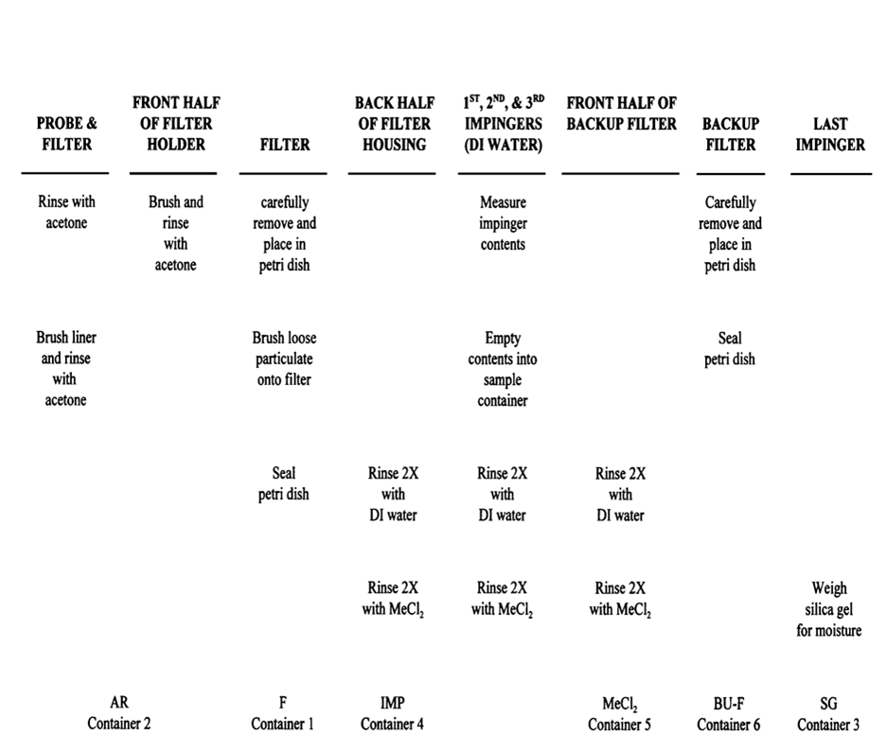

Figure 6: Sample Analysis Flow Diagram
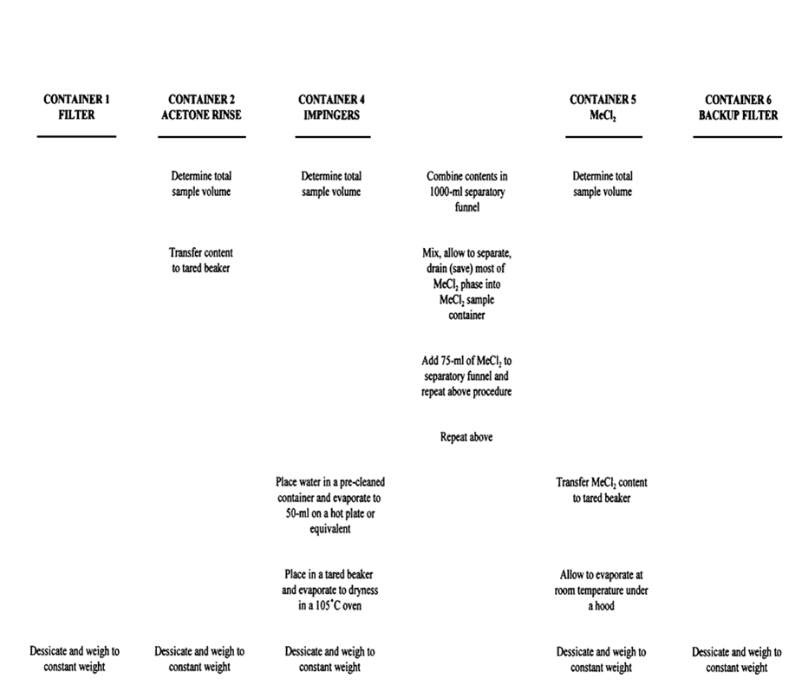

5.2 Process Data
In this chapter, include the following:
- Description of procedures for obtaining process stream and control equipment data.
- Frequency of collection of this information.

Note: It is the responsibility of the sampling contractor to ensure the collection, accuracy and reporting of the process data. Source Testing reports without proper supporting process data may be rejected by the Ministry's Regional Director.

Example of Process Data Discussion (Chapter 5.2)
The following process operation data will be collected:
- Number of press loads during EFB inlet/outlet testing;
- Number of press loads during press vent testing;
- Dryer inlet and outlet temperatures;
- Belt speed;
- EFB bed voltage and current; and
- EFB ionizer voltage and current.

The [Process Monitor] will count the number of press loads, and obtain the dryer data from the central control panel and the EFB data from the EFB control panel every 5 minutes.

6.0 Internal QA/QC Activities

6.1 QA/QC Procedures
In this chapter, provide the following for each test method:

Data sheets (see example on following page).

Example of Velocity Field Data Sheet (Figure 7)

Date:
Run No.:
Plant:
Start Time:
Test Location:
Operator:
Pitot ID No.:
Pitot coeff: Cp =
Last calibrated Date:
Pitot condition:
Gauge sensitivity:
Req'd: mm H2O
Actual: mm H2O
Calibration:
Pre-test:
Post-test:
Leak check: (None)
Pre-test:
Post-test:
Temp. ID No.:
Temp. calibration: (1.5% abs) Pre-test:
Post-test:
Barometric pressure gauge calibration: (1 in. Hg)
Pre-test:
Post-test:
Barometric pressure: Pb = in. Hg
Static pressure: Ps = in. Hg
Pitot configuration/assembly:

Sketch/dimensions:
Schematic: Cross-Section

Port/Traverse Pt | Δp mm H₂O | Stack temp. °C
[Enter info] | [Enter info] | [Enter info]
[Enter info] | [Enter info] | [Enter info]

Checked for completeness by (Signature/Title):

6.2 QA/QC Check Lists
Example of a QA/QC Check List
- Continuous Emission Monitors
- Measurement System Performance Specifications
- Analyzer Calibration Error: Less than ±2% of the span for the zero, mid-range, and high-range calibration gases
- Sampling System Bias Less than ±5% of the span for the zero, and mid- or high-range calibration gases
- Zero Drift: Less than ±3%of the span over the period of each run
- Calibration Drift: Less than ±3% of the span over the period of each run
- Interference Check: Less than ±7% of the modified Method ON-6 result for each run
- Analytical Range: The span of the monitoring system (range) shall be selected such that the pollutant gas concentration equivalent to the emission standard is not less than 30% of the span. The calibration gas shall be selected equivalent to mid-range of the span of the monitoring system.

In addition to the above, include discussion of any special QC procedures.

6.3 QA/QC Checks for Data Reduction and Validation
In this chapter, describe the following:
- Procedure for assuring accurate transfer of raw data and accuracy of calculations.
- Data quality indicators, such as
- Comparing process O2 monitor and CEM O2 data,
- Comparing flow rates by different sampling trains,
- Isokinetic checks,
- Comparing relative concentrations,
- Comparing data with previous field test results (if applicable), and
- Running mass balances.

6.4 Sample Identification and Custody
- Person responsible.
- Sample identification and chain-of-custody procedure.
- Sample identification label.
- Chain-of-custody form.
- Sample log sheet.

Note: The scheme for identifying samples should be logical and easily deciphered, e.g., 2I-Pa-F means Run No. 2, inlet, particulate matter sample and filter.

7.0 Reporting and Data Reduction Requirements

7.1 Report Format
In this chapter, include:

Table of Contents for the test report

Example Table of Contents for Test Report
The Table of Contents for the report will be:

Table of Contents (include page number)

List of Figures

List of Tables

- Introduction
  - Summary of Test Program
  - Key Personnel

- Source and Sampling Location Description
  - Process Description
  - Control Equipment Description
  - Flue Gas and Process Sampling Locations

- Summary and Discussion of Results
  - Objectives and Test Matrix
  - Field Test Changes and Problems
  - Discussion of Results (at least one for each objective)
  - Recommendations
  - Conclusions

- Sampling and Analytical Procedures
  - Emission Test Methods
  - Process Test Methods
  - Sample Identification and Custody

- QA/QC Activities

Appendices:
A - Results and Calculations
B - Raw Field Data and Calibration Data Sheets
C - Production and Pollution Abatement Equipment Operating Data D - Certificate of Approval
E - Sampling Log and Chain-of-Custody Records F - Analytical Data Sheets
G - Audit Data Sheets
H - List of Participants
I - Additional Information
J - Qualifications of Sampling Tea

7.2 Data Reduction and Summary
In this chapter, include:

Data summary tables; include units (e.g., kg/kJoule, kg/tonne of product, dscm corrected to 11% O₂).

The example (on the following page) is for only one of the sets of measurements. Similar tables should be made for all sets of data.

Example of Summary Table Format of Emission Data (Table 3)
Table 3 shows the format to be used to summarize the data.

Method/ Compound | Units | EFB Inlet – Run 1 | EFB Inlet – Run 2 | EFB Inlet – Run 3 | EFB Inlet – Avg | EFB Outlet – Run 1 | EFB Outlet – Run 2 | EFB Outlet – Run 3 | EFB Outlet – Run Avg | Press Vents – Run 1 | Press Vents – Run 2 | Press Vents – Run 3 | Press Vents – Run Avg
[Enter info]
[Enter info]
[Enter info]

8.0 Plant Safety Requirements

8.1 Safety Responsibilities
Identify the following individuals:

- Person responsible for ensuring compliance with plant entry, health, and safety requirements
- Name:
- Position:
- Telephone Number:

- Facility person or safety officer who has the authority to impose or waive facility restrictions
- Name:
- Position:
- Telephone Number:

- Tester who has authority to negotiate with facility person any deviations from the facility restrictions
- Name:
- Position:
- Telephone Number:

8.2 Safety Requirements
- Safety Equipment. Please indicate which of the following are required on site:
- Head Protection
- Foot Protection
- Eye Protection
- Hearing Protection
- Safety Belt or Harness*
- Respiratory Equipment*
- Other Protective Clothing or Equipment
- Safety Training Session
- Date of Session if Required

- Sampling Locations:
- Outdoors
- Indoors

- Approximate Temperature of Sampling Location Work Area

- Please indicate access to the sampling location:
- Stairs,
- Fixed Ladder,
- Scaffolding,
- Portable Ladder, and
- Crane/Lift

- Other Safety Requirements:

9.0 Personnel Responsibilities and Test Schedule

9.1 Test Personnel Responsibilities and Detailed Schedule
In this sub-chapter:
    - Provide a list of sampling staff, clearly identifying the project manager and the field team leader.
    - Provide a table or text detailing the test schedule.

Example of List of Test Personnel and Responsibilities (Table 4)
Responsibility | Test Personnel
1. Project Manager/Field Coordinator | [Name of Individual]
2. Sampling Team Leader | [Name of Individual]
3. Field Technician | [Name of Individual]
4. Field Technician | [Name of Individual]
5. CEM Operator | [Name of Individual]
6. Process Data Collector | [Name of Individual]

Example of Daily Test Schedule for Test Program (Table 5)
Monday  July 29, 20XX | Tuesday  July 30, 20XX | Wednesday  July 31, 20XX | Thursday  August 1, 20XX
- Travel to site  - Establish test team  - Plant communications  - Set up test locations  - Conduct preliminary measurements  - Set up lab for sample recovery | - Complete 2 test runs | - Complete 3rd test run  - Pack up all but Methods 25 and 25A runs  - Conduct 2 additional Method 25/25A runs  - Collect 2 evacuated cylinder samples  - Rest of staff drive home  - Afternoon: Contingency test day | - Conduct 1 additional Method 25/25A run  - Collect 1 evacuated cylinder sample  - Restore sites  - Remaining staff drive home  - Contingency test day

9.2 Test Preparations
In this sub-chapter (if applicable), describe or identify the following:

- Construction of special sampling and analytical equipment
- Description
- Dates for completion of work

- Modifications to the facility, e.g. adding ports, building scaffolding, installing instrumentation, and calibrating and maintaining existing equipment
- Description
- Dates for completion

- Services provided by the facility, such as electrical power, compressed air, and water
- List of all services to be provided by the facility
- Description of modifications or added requirements, if necessary

- Provide access to sampling sites
- If modifications are necessary, indicate the modifications

- Provide sample recovery area
- Description
- If a mobile recovery area or laboratory is used, installation location, and dates for installation

10.0 References
United States Environmental Protection Agency, Preparation and Review of Site- Specific Test Plans, December 1991.

