Water Well Information System (WWIS)
Well Record Data Report - CSV Files September 2017

The Ministry of the Environment and Climate Change has modernized the Well Record Search request process, enabling the public to directly access Well Record data through Ontario.ca.
This guide will instruct users on how to access information similar to what was previously provided through the Well Record Request – Form B Data Print Out service by using the Well Record Data Report files.
The files are organized by County. This instruction uses DUFFERIN County as an example.
Printing Format
After opening the CSV files in excel, the layout can be formatted to make viewing and printing easier.
Step 1: Click on the right border of column J and drag to expand the column width.
Step 2: Select all columns, right click and select Format Cells.
Step 3: In the Alignment tab select Wrap Text.
Step 4: Click OK.
The format of the data will now be more consistent with the Form B - Well Record Computer Print-Out results as shown below.
Enable Filtering by UTM Coordinates
This process separates the UTM Easting and Northing Coordinates and allows filtering of Records based on UTM location.
Step 1: Enter the following formula in cell M2.
=IF(ISBLANK(B2),0, VALUE(MID(B2,4,6)))
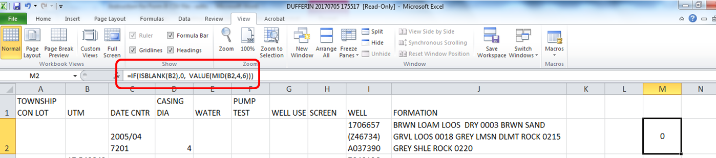
Step 2: Enter the following formula in cell N2.
=IF(ISBLANK(B2),0, VALUE(MID(B2,11,7)))
Step 3: Copy cells M2 and N2 by selecting the cells and clicking the copy button.
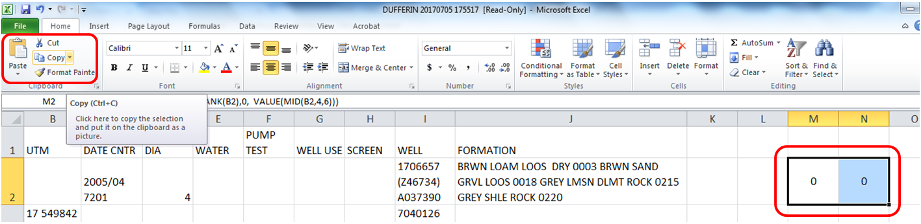
Step 4: Select column M and click the paste button. Column M now contains Easting values and column N now contains Northing values.
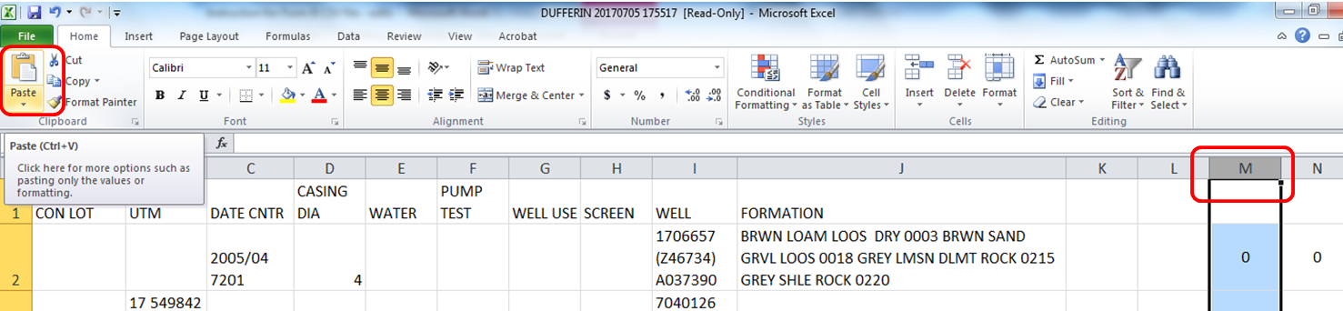

Step 5: Select column M and N. In the Data tab, click Filter to enable filter.
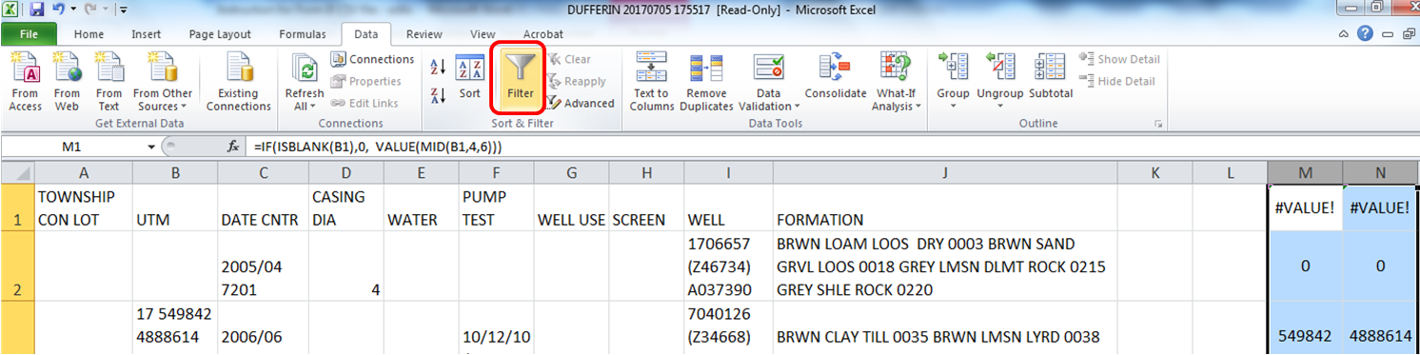

Step 6: Click the down arrow on column M and select [Number Filters], [Between …]
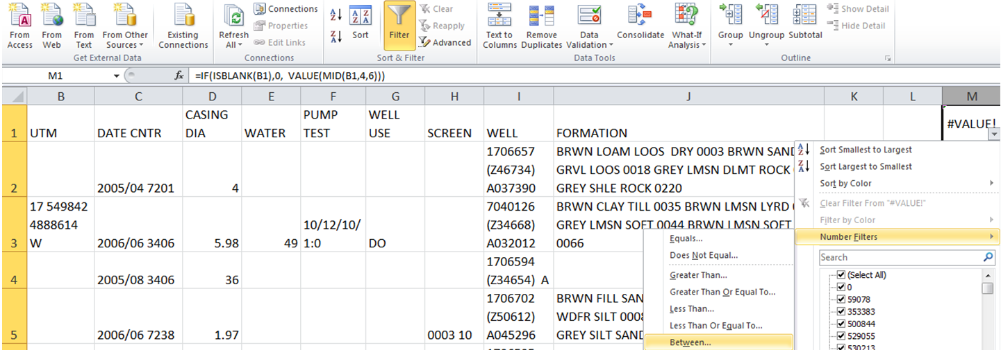

Step 7: Enter the pair of Easting Coordinates to filter by. The first value must be the smaller number.
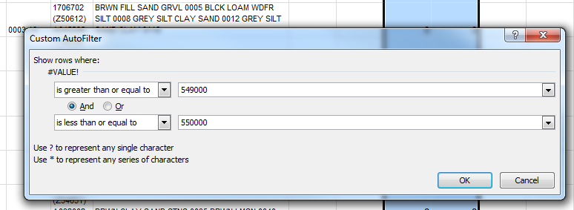
Step 8: Click the down arrow on column N and select [Number Filters], [Between …]
Step 9: Enter the pair of Northing Coordinates to filter by. The first value must be the smaller number.
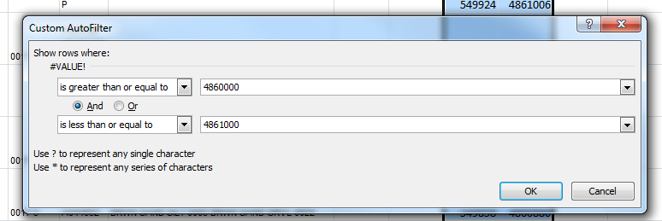

For the County of Dufferin, this filtering process returns 4 Well Records between the two pairs of coordinates used. This information can now be saved or printed.
